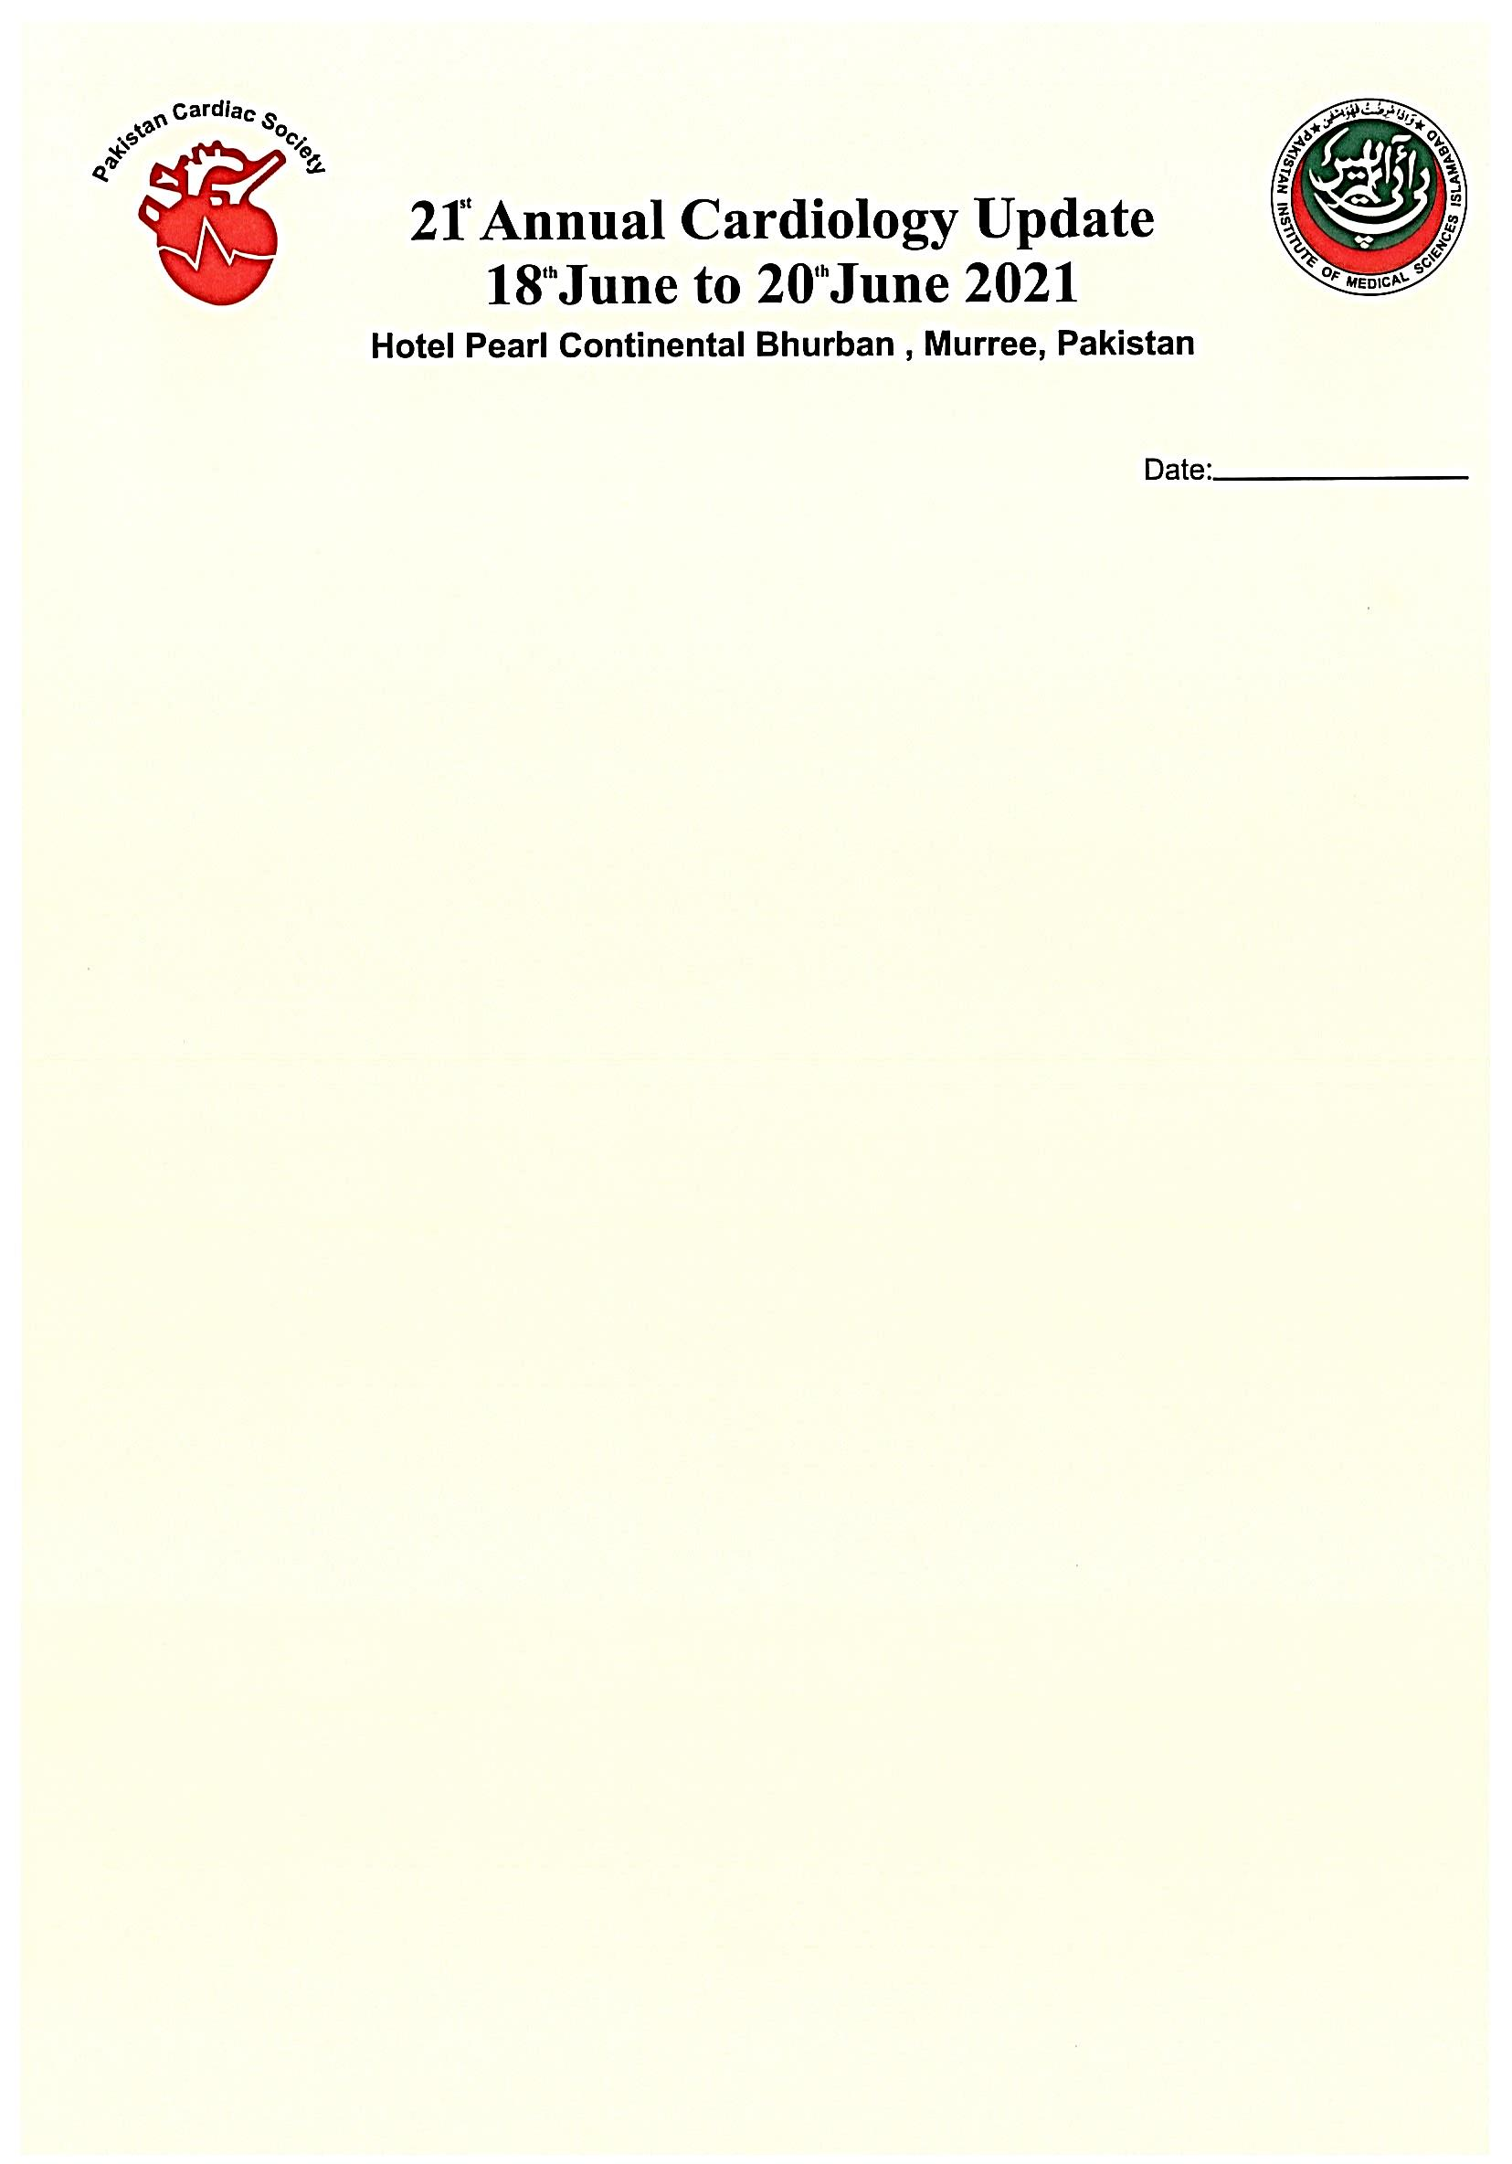

To,

The President PCS

**Subject: 21st Annual Cardiology Update PC Burbhan**

Sir,

As per council decision, I as convener of 21st cardiology conference has started the preparations of conference. PC Bhurban hotel has been booked from 18th to 20th June 2021.

As per SOPS of Covid-19 this year’s conference will be a hybrid event. Arrangements in this regard are ongoing. We will be able to have live talks broadcast in conference hall, Hotel rooms, YouTube, Facebook. This will be interactive broadcast.

Conference website has been launched. I request you to send invitations to other cardiac societies. Invitation letter is attached. Two hybrid sessions with international speakers, penal experts have been finalized.

Session one on 18-06-21 at 7:00 pm- 8:00 pm pst. (Duration 1 hour)

Session two on 19-06-21 at 11:00 am- 2:00 pm pst.

You are requested to invite speakers and chairpersons/ penal of experts for the above sessions. Further details can be finalized later.

We want to collaborate with the sister organization like APSL, ESC, ACC, PISC and Pakistan Hypertension league for active participation in conducting academic program.

I may be allowed to use LOGOS of cardiac societies on conference letter-head and website.

Yours sincerely,

Convener

**Akhtar Ali Bandeshah Muhammad Naeem Malik**   
 **Convener Patron**

**CONFERENCE SECRETARIATE  
Department of Cardiology  
Pakistan Institute of Medical Sciences, Islamabad  
Ph: # +92-51-9260330 Email:** [**cardiologygupdate21@gmail.com**](mailto:cardiologygupdate21@gmail.com) **WhatsApp Group: cardiology update, WhatsApp # +92 321 5034320**